SST 309: Geo-Diary Erin Francis

Belmont Michigan – The Beginnings

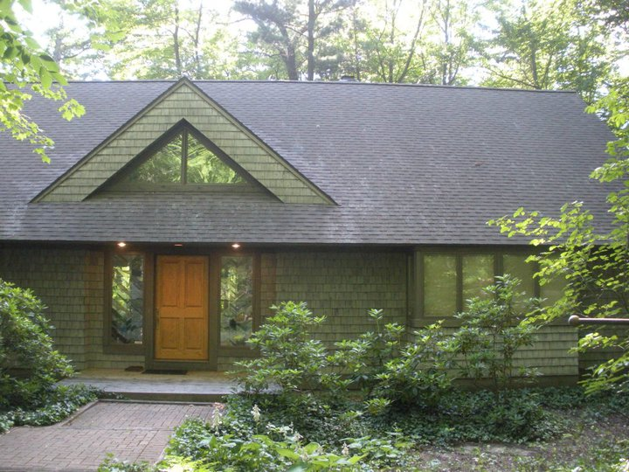
3 PM, September 10, 2010 West
- This is the house that I grew up in and where my parents live now. I visit them about once a month. We live in the woods in Belmont. (Relative Location, Human/ Enviromental Interaction)

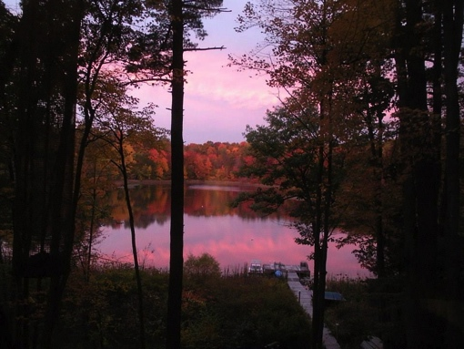
6 PM, October 15, 2013 West
- Behind my house is Mirror Lake. We are the only house on the lake. I enjoy fishing, swimming, and hanging out by the water. (Relative Location, Human/Enviromental Interaction, Natural/ Physical Characteristics of Place)
Grand Valley State University

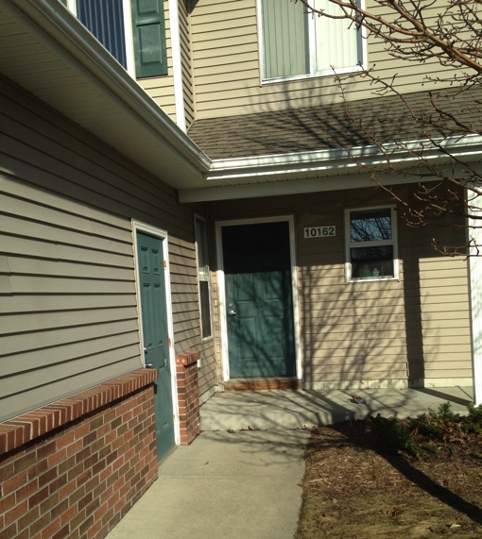
5:45 PM March 23, 2015 East
- This is my apartment 10162 Laker Lane. It is right off campus in Campus View. I live here with my 3 roommates. (Absolute Location)

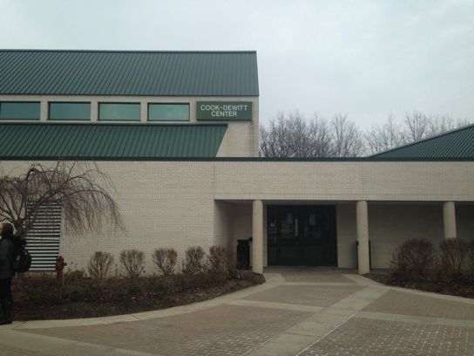
5:21 PM March 19, 2015 North East
- The Cook Dewitt Center is a place on campus located near the clock tower that I spend a lot of time at. The religious organization I’m involved in, Campus Ministry, has offices here. (Human/Cultural Characteristics, Relative Location, Movement of Ideas)
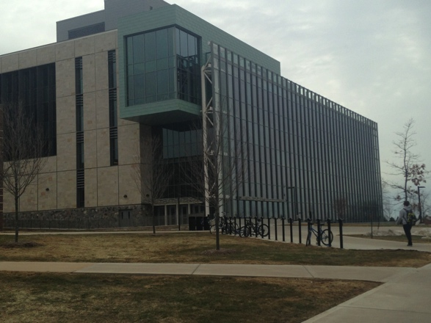
5:22 PM March 19, 2015 South West
- The Mary Idema Pew Library is a beautiful building on campus where many students come to study and learn. It is located right next to Kirkhof in the center of campus. (Relative Location, Movement of Ideas)

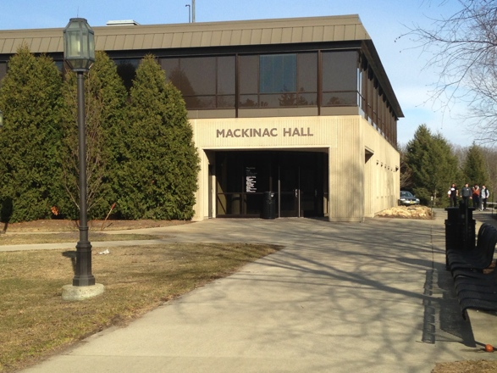
5:26 PM March 23, 2015 East
- Mackinac Hall is where I attend the majority of my classes at Grand Valley. It is located on the North end of campus near Fresh Foods Co. (Relative Location, Movement of Ideas)

My Workplace

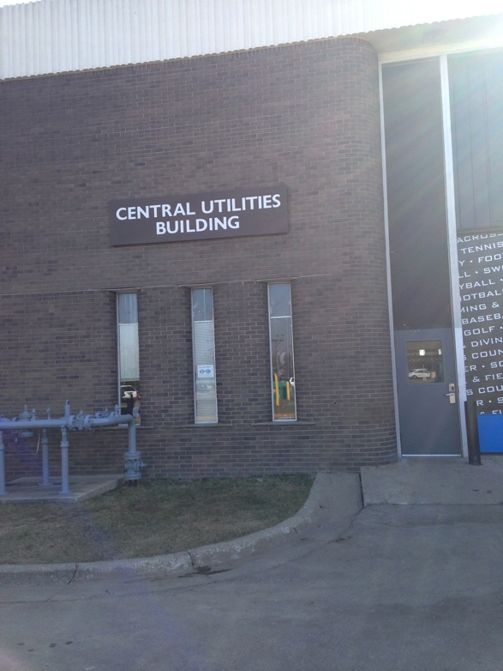
10:56 AM March 20 East

- I work at the Central Utilities Building. This building provides water, gas, and electric utilities for the entire campus. I have an office job and file the bills for the utilities and make sure all of the bills get paid. The Central Utilities building is located on the very North end of campus close to M-45. (Use of Resources Human/Environmental Interaction, Relative Location)

Places of Worship

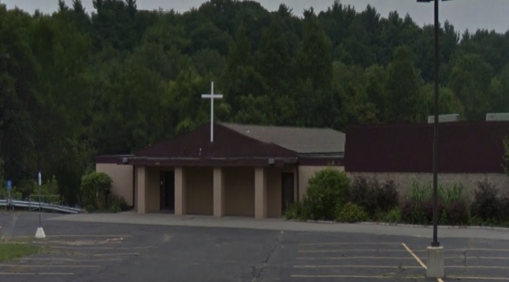
6 PM, August 8, 2012, East

- When I am at home and growing up I went to Maranatha Bible Church every Sunday and Wednesday. It is located at 4444 Stony Creek in Comstock Park. (Absolute Location, Human/Cultural Characteristics of Place)

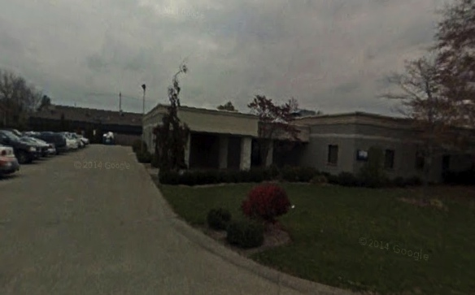
1 PM October 10, 2014, North East

- Since I came to Grand Valley I have been going to Alive Ministries church in Jenison, because it is closure to Grand Valley than Maranatha. (Relative Location, Human/Cultural Characteristics of Place)

Grocery Shopping

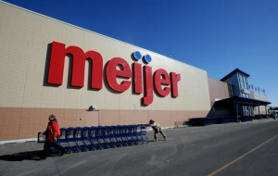
4 PM March 22, 2015, South

- Meijer in Standale is where I shop for groceries and other necessities about every other week. It is on the 50 bus route to Grand Valley, which makes it an easy stop when I need to pick something up. (Relative Location, Movement of goods)

My Get Away
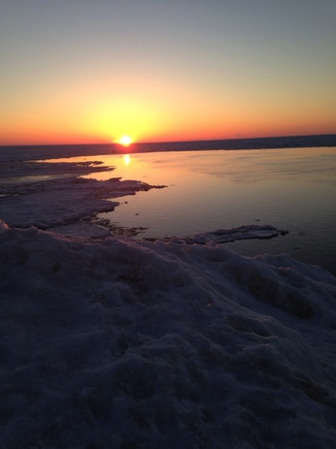
7:55 PM March 21, 2015 West

11. The Grand Haven beach has always been a vacation place for my family. I love to go to the beach and spend time by the water. (Natural/Physical Characteristics Great Lakes Region)

